**Exp. 8 Virtual Hard Disk**

**Aim:**

To create a Virtual Hard Disk and allocate the storage using virtual box.

**Procedure:**

* Open virtual box application
* Then click on new button to create a new VM
* Enter the name and select the required ISO file
* Enter credentials like username and password
* Select required hard disk size and memory size, along with number of CPUs
* Now the VM is created

**Output:**

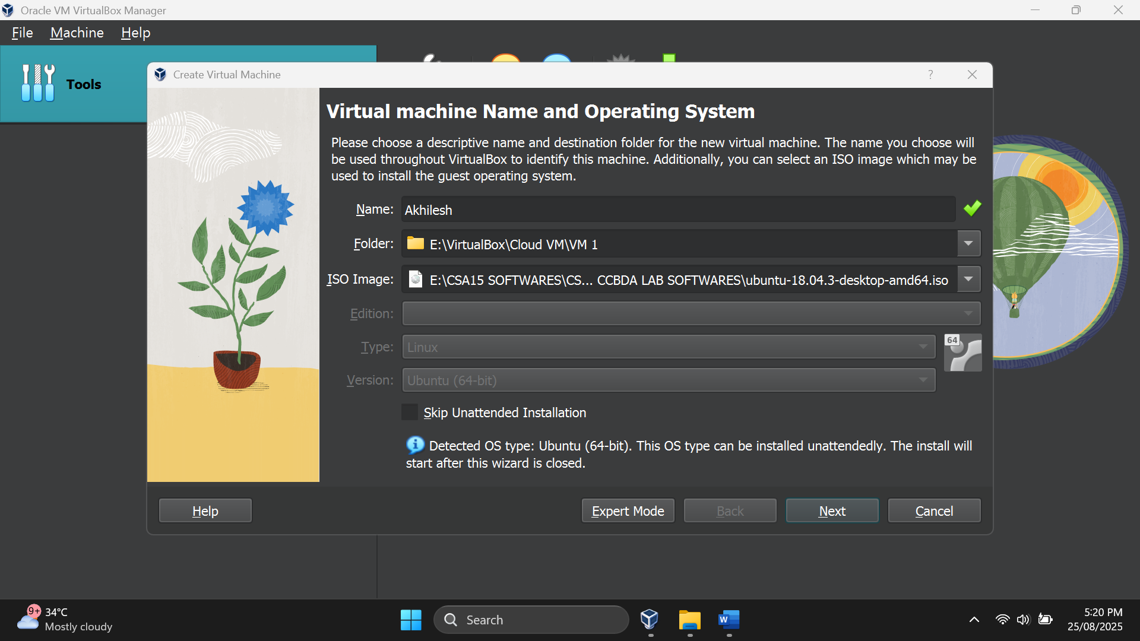

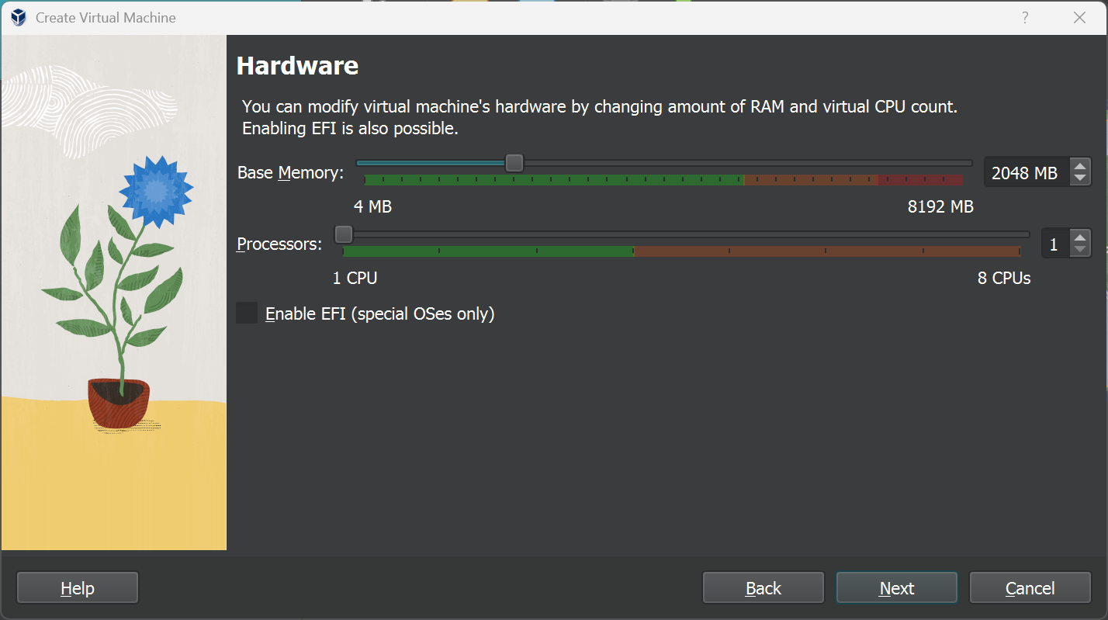

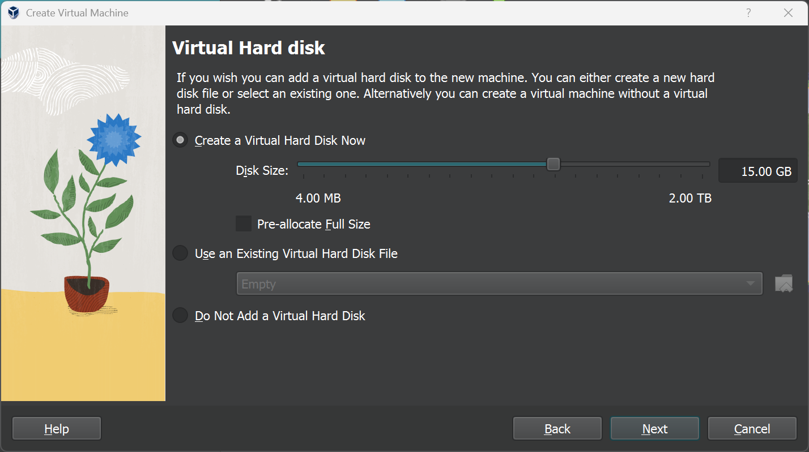

**Result:**

Thus the virtual hard disk was created and run successfully